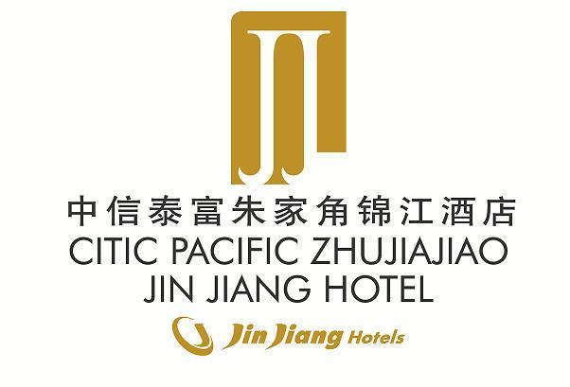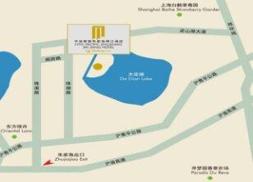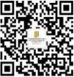

**Tip: For reservations, please fill in your reservation information and send it to the hotel mailbox at jeffrey.jiang@zhujiajiao.jinjianghotels.com to confirm, thank you!**

Warmest greetings from CITIC Pacific Zhujiajiao Jin Jiang Hotel! We are pleased to confirm your reservation as follows:

**Booking Details:**

**Guest Name:**

**Confirmation Number:  
Arrival Date :   
Departure Date :   
Room Type:**

**Number of Rooms:   
Number of Guest:   
Daily Room Rate:   
Method of Payment:**   
Inclusive: Daily Breakfast, Complimentary High-speed Internet, and Free Parking  
Remark: CC2019

To:

Company:  
Fax:  
Date:

**Hotel Confirmation**

TEL: +86-21-61226688  
Address: 666 Zhuhu Road, Shanghai 201713

Please contact us before your arrival at TEL 86-21-39277888 or concierge@zhujiajiao.jinjianghotels.com for pre-arranged transportation pick-up.  
** Airport Transfer Service (one-way): Hongqiao Airport – RMB650; Pudong Airport – RMB800

*Early check-in is subject to hotel availability. Please contact us at least one-day in advance if needed  
*Your reservation will be held until 6:00pm (hotel local time) on day of arrival unless you provide us a credit card guarantee or deposit in advance.  
*Please contact us at least 24 hours prior to your scheduled arrival date if you would like to revise

**Booking Conditions:**

**Destination Information:**

Distance to Main Attractions:   
Zhujiajiao Ancient Town 1 km  
* Within 15mins walking distance   
Oriental Oasis 4 km  
Outlets Shopping Center 23 km  
National Exhibition & Convention Center 33 km  
Hongqiao Airport (SHA) 35 km

Thank you for choosing CITIC Pacific Zhujiajiao Jin Jiang Hotel. We look forward to welcoming you soon.

Warmest Regards,  
  
Reservations Department

Please follow us on Wechat (ID: CPJJPR ) for more information and